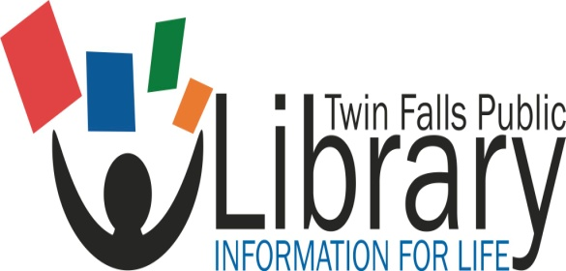 Board of Trustees
Twin Falls Public Library
Wednesday, July 13, 2022 4:30 p.m. TFPL Board Room
- Roll call and introductions
- Approval of the agenda: July 13, 2022 (Action)
- Approval of minutes of last meeting: June 8, 2022 (Action)
- Approval of expenditures and financial accounting:
May bills/Financial and Statistical report: June 8, 2022 (Action)
- Public Comment (3 minutes)
- Communications/Correspondence: Summer Reading events

- City Council Liaison report (Nikki Boyd)
- Foundation Liaison report (Jennifer Hall)
- Library Director report: Update to the hiring of Building Services Department Head; First Amendment Audit in libraries; LYNX! Consortium update; Budget numbers; Trustee Elly Young term ending December 2022; Information to share
- Business Issues: Consideration of going fine free – Jill Fleming (Action); Update to COVID-19 Employee procedures (Action);

- Future agenda items
- Scheduling meeting date
Meeting Date August 10, 2022
- Adjourn

